**Barbershop 2: Back in Business**

*Analysing a family-owned business presented by an American comedy film.*

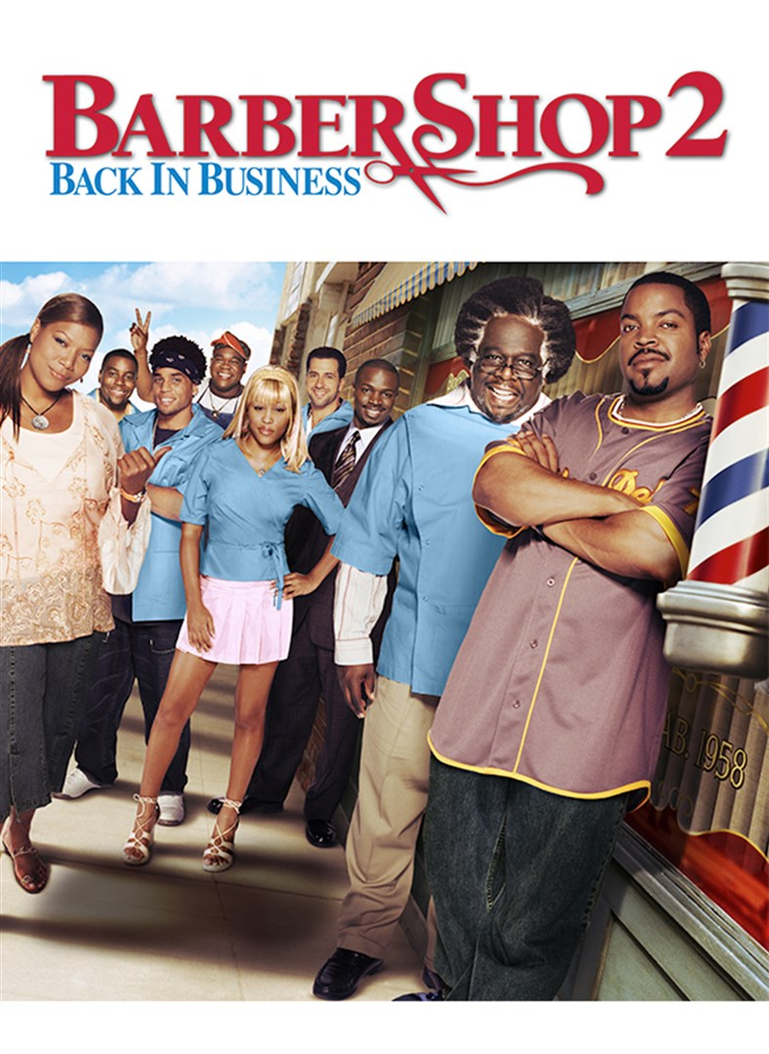

Student:

Course:

Professor:

Date: 5/3/2021

Word Count: 2.200

**Introduction**

The American comedy film **“Barbershop 2: Back in Business”** that is analysed in this essay, presents an interesting portrayal of a Family-Owned Business (FOB) through the lens of generations that is later affected by the aspect of new powerful competitors, threatening its existence as a family enterprise. This is alongside other internal inefficiencies as far as employee management is concerned and political factors surrounding its existence (Lopez-Fernández, and Atristain-Suárez, 2019). This essay identifies and analyses the family business themes as demonstrated in the “Barbershop 2: Back in the Business” film and incorporates various theories and theoretical models that aid the development of a concise and concrete analysis. **Table 1** below briefly illustrates the plot of the film and the characters involved.

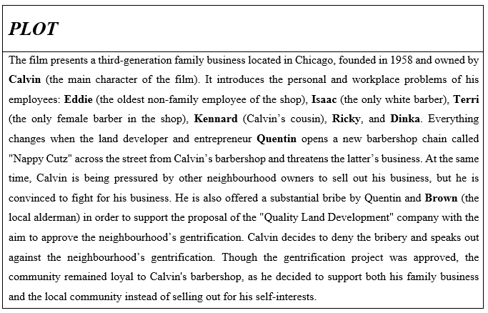 Table 1: The Plot of the Film.

**Discussion**

The film refers to the (third-generation) family local barbershop business owned by Calvin, who has a wife and a baby son. It survives with six employees with different relationships with each other, who face both personal and workplace problems during the film. The operation and management of the barbershop fit the definition of a FOB, managed by a nuclear family. This FOB has an overarching vision that may span across later generations for the benefits to be gained by the family (Shen, 2018). Based on the above the complexity of (a) the business and (b) the family can be identified as “Low” and “Very Low - Low” respectively. However, if the family business was similar to IKEA, a multinational company run by the second generation with a complex ownership structure (Tarnovskaya and de Chernatony, 2011), both family and business complexity would be very high (Table 2).

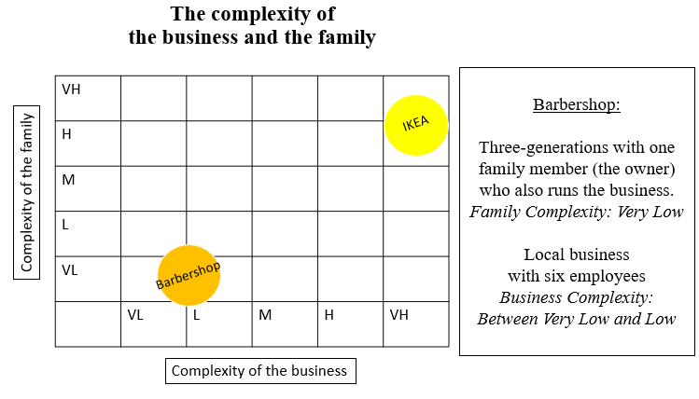

Table 2: The complexity of the business and the family.

This essay uses the Three-Circle model (Family, Business and Management circles) to (a) provide information about the family business environment and (b) graphically illustrate the role of each character in the family business (Davis and Tagiuri, 1982) **(Table 3).**

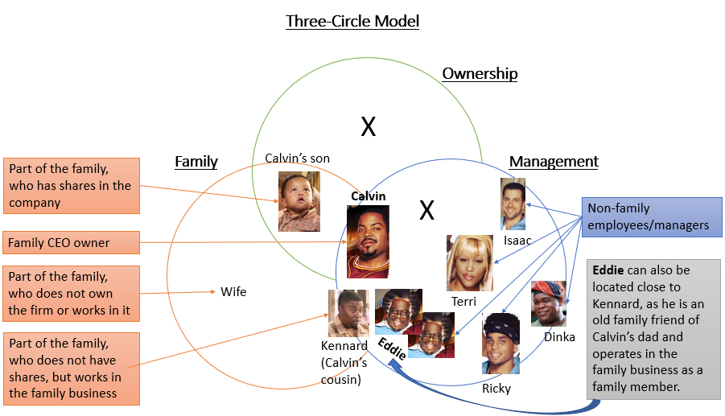

Table 3: Three-Circle Model.

In Table.3 above, Calvin is placed at the centre where the three circles overlap, as he is the owner, part of the family, and manager. All six employees are located in the management circle, while the son is placed in the ownership and family circles (as the heir of the barbershop). The wife is placed in the family circle only (as she does not work in the family business) and Kennard, Calvin’s cousin, is located in both the family and management circles (as he is part of the family and works in the family business). Eddie, one of the six employees and the oldest one working in the business, can also be located close to Kennard, as he is an old family friend who operates in the family business as a family member. This can be seen from several incidents that occurred and presented in the film, some of which were (a) the rent exclusivity factor, where both Calvin’s father and Calvin did not receive rent from Eddie and (b) Eddie’s unconditional support to Calvin’s father and Calvin when they were facing critical problems with the barbershop. Therefore, the connections between the family and the business and the roles each member plays can be easily identified when using the Three-Circle model.

The relationship between Calvin and his son can be linked to the family business theories. Specifically, members of the family may be introduced and nurtured to fulfil the family duties especially taking over the business from their parents or ancestors at a very young age (e.g., Calvin and his son as the heir of the barbershop) (Cirillo, and Mussolino, 2019). This can be seen from the scene where Calvin talks to his baby son about the problems he faces regarding the barbershop and ends up telling him that he will take over the family business. This scene can be described as a comic scene, as the baby begins to cry when his father announces his future duty. Therefore, the succession-planning process of the family business, which includes the transfer of leadership with the view to continuing the family business (Davis, 1968) is a private affair and concerns only the owner (Cesaroni, and Sentuti, 2017), who assigns his son as the next leader of the barbershop.

Individuals within the family circle (i.e., wife) who do not have ownership only aid in influencing the decision-making of the heir in charge (Williams, Pieper, Kellermanns, and Astrachan, 2018; Alkahtani, 2021). This can be seen when Calvin’s wife exerts influence over him through persuasion when convincing him to hire his cousin Kennard. However, these individuals are not included in the share with voting rights of the business.

It is also interesting to view the relationship between Kennard and Calvin. Based on the latter’s attitude, the company cannot be characterized as a “family-first business”. This can be explained as Calvin does not wish to hire Kennard, even though he is part of the family. In particular, Calvin implies that he was influenced by his wife to hire Kennard and announces to him that he is in a probation period (in front of all employees). Thus, Kennard must work hard to earn a chair at the barbershop.

The SWOT model (Strengths, Weaknesses, Opportunities, and Threats) is an instrumental tool in analysing the internal and external characteristics of the performance of the business (i.e., the barbershop) and it is used in this essay (Leigh, 2009) (Table 4).

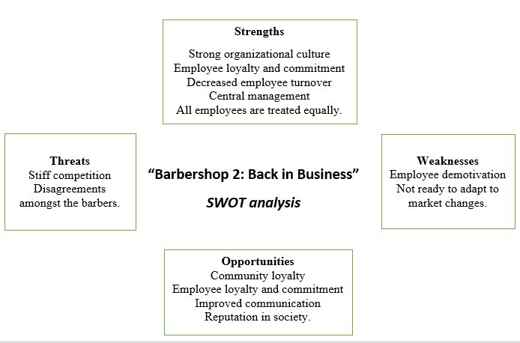

Table 4: SWOT Analysis.

The strong organizational culture (i.e., employee diversity and the values of the family business) and central management exist as the **strength** of the barbershop. The central management is solely undertaken by Calvin that affects its operations. Family businesses have a characteristic where, the head who is also the heir has the total authority and the final say regarding the operation of the business (Astrachan, and Botero, 2018). This is reflected in the governance pattern whereby Calvin overrules the decision by Isaac (one of the employees) to be considered as the most special, top-class barber who enjoys more benefits compared to others (Saidon et al, 2019). Thus, the decision on the management of employees including motivation lies in decisions reached by the owner, making it one of the rigid systems that any organization can adapt and maintain (Astrachan, Astrachan, Campopiano, and Baù, 2020; Hernández-Linares, Sarkar, and Cobo, 2018). Calvin also exhibits independence and persistence when he replaces the new design of the barbershop with the old one (at the end of the movie).

Additional strengths can be identified in Calvin’s barbershop. Specifically, the film shows that Calvin treats all his employees equally. Various studies have shown that “nepotism” may lead to a business decline or even bankruptcy (Bennedsen et al., 2007; Gomez-Mejia et al., 2011). Moreover, another strength of a business is when individuals share similar values and common goals. As a result, employee commitment and loyalty may increase, and employee turnover may decrease (Davis and Harveston, 1998; Dyer, 1986; Le Breton‐Miller et al., 2004; Nelton, 1991; Handler, 1990; Morris et al., 1997). This theory is linked to the film’s plot, as Calvin and the other barbers are committed to maintaining the business, this is being a common goal. Due to the latter, all non-family employees became even more committed and loyal to the business and the former employees (Jimmy and Isaac) decided to return to the family business, as they appreciated Calvin’s integrity.

Amongst the **weaknesses** affecting the barbershop is the lack of development and adaptation to market changes. In the modern world, economies are characterized by ever-dynamic operational, structural, and process environments, demanding the existing and old enterprises to constantly evolve in their operations (Herrero, 2017). This is due to the ever-emerging new entrants to the market with technological advancements that tend to create a technological disruption and a dilemma for the existing businesses as to whether to adopt them. Calvin appears in a state of panic when he changes fundamental factors of his business regarding its operation to match his competitors. Employee demotivation is another weakness that needs to be considered. In this case, the barbers operated according to the decisions and the final word of the leader.

Moreover, **threats** are majorly caused by Calvin’s competitor, Quentin. Also, threats can arise due to disagreements amongst the barbers. Despite these threats, **opportunities** for the business lie in customer loyalty and its reputation in society (Petlina, 2015). Based on the film, it seems that Calvin gains a competitive advantage by (a) encouraging communication improvements amongst the barbers and (b) focusing on the community’s loyalty.

Furthermore, the film exhibits the effect of the dictator and dynasty system as the expectation of a lifelong commitment to the entire family (Byrne, Fattoum, and Thébaud, 2019). It is clear that the head of the family business serves for life and can only be replaced if the existing leaders are dead and the heir is capable of handling the business. Results on the tenure of the CEOs in family firms reveal that they often tend to lead for an average length of approximately five times longer than non-family businesses (Parada, and Dawson, 2017). This is because of the sense of duty to manage the enterprises until the heir is mature enough to take charge of the business (Rondi, De Massis, and Kotlar, 2019). According to Hasenzagl, Hatak, and Frank (2018), it is likely for the CEO of a family business to feel the need to maintain and at the same time consider alternative career paths putting the business at risk. This theory can be found in the story exhibited in the film “Barbershop 1”, where Calvin was running the family business, but he was also thinking of pursuing another career path. However, in the second movie, Calvin devoted his life to the longevity of the barbershop.

Additionally, basic concepts of the stewardship theory can be identified in the characters and the plot of the movie. Calvin as a “steward” acts motivated to assist the collective good of the firm as well as of the neighborhood (Davis, Schoorman and Donaldson, 1997; Donaldson and Davis, 1991). Particularly, Calvin is offered a substantial bribe of 200.000 dollars from Quentin (the new competitor) and Lalowe Brown (the local alderman) in exchange for his support of the city gentrification legislation. Calvin refuses the bribery and aims to (a) keep the barbershop intact from the new competition and (b) help the community survive the changes to come in the neighborhood. He is also devoted to the success of the business by sacrificing personal benefits (Davis et. al., 2000). Ultimately, Calvin kept the family business intact and gained a competitive advantage by denying bribery. In other words, Calvin exhibits “Stewardship” by acting responsibly and assigning more value to teamwork and community than self-interest.

An example of a family business that can be compared to the FOB presented above is that of Walmart company. The latter is a family business in the retail industry for the past decade and has changed its operation and management over the years (Manzaneque, Diéguez-Soto, and Garrido-Moreno, 2018). It strives at ensuring that its management is led effectively for the interest of the family as opposed to individual achievements (Calabrò et al, 2019). The employees of Walmart were not part of the ownership of the organization but performed their services for salary, and wages. The leadership and management were hereditary and the CEO part of the family where the eldest son was nurtured and trained while at a tender age to manage the business. Thus, it is only old age and death that allows the change of CEO in the family (Stieg, Hiebl, Kraus, Schüssler, and Sattler, 2017).

Similarities can be identified in the two companies (Calvin’s barbershop and Walmart) when comparing some of their features. Though both companies encourage changes as regards the operation, they do not easily change their CEO. Furthermore, in both cases, a) the employees are not part of the ownership, and b) the heirs are expected to take over the management of the business. However, a difference between the two companies that can be identified is that Walmart’s management focuses on the family’s interests, while Calvin’s barbershop focuses on the community’s and business’s interests.

**Conclusion & Recommendations**

To conclude, the film “Barbershop 2: Back in Business” portrays perfect characteristics of the family business and factors within their environment that affect their economic life. This is with regards to the relationships of the employees, the leadership of the business as well as its strengths, weaknesses, threats, and opportunities. The strategies of the business are affected by the leadership aspect of the internal operation as well as by the political and competition aspects. Though the heir faced numerous challenges, he succeeded in the top leadership position, as he exhibited “stewardship” and ensured that the family business would exist for future generations, this being opposed to his short-term self-interests. Based on the SWOT analysis, the writer identified that such leadership may greatly be threatened by new entrants in the market that provide advanced and more sophisticated operational systems. Hence, competitive advantage is essential and can be obtained when the leaders encourage improvements in employee interpersonal relationships, focus on the customers’ and community’s loyalty and enhance the company’s reputation by engaging in stewardship activities.

**Reference list**

Alkahtani, A.W., 2021. Family-Owned Businesses in Saudi Arabia: Challenges and Solutions from a Legal Perspective. Int. J. Contemp. Manag. Inf. Technol, 1(2), pp.16-22.

Astrachan, C.B. and Botero, I.C., 2018. We are a family firm. Journal of Family Business Management.

Astrachan, J.H., Astrachan, C.B., Campopiano, G. and Baù, M., 2020. Values, spirituality and religion: Family business and the roots of sustainable ethical behavior. Journal of Business Ethics, 163(4), pp.637-645.

Bennedsen, M., Nielsen, K.M., Pérez-González, F. and Wolfenzon, D., 2007. Inside the family firm: The role of families in succession decisions and performance. *The Quarterly Journal of Economics*, *122*(2), pp.647-691.

Byrne, J., Fattoum, S. and Thébaud, S., 2019. A suitable boy? Gendered roles and hierarchies in family business succession. European Management Review, 16(3), pp.579-596.

Calabrò, A., Vecchiarini, M., Gast, J., Campopiano, G., De Massis, A. and Kraus, S., 2019. Innovation in family firms: A systematic literature review and guidance for future research. International Journal of Management Reviews, 21(3), pp.317-355.

Cesaroni, F.M. and Sentuti, A., 2017. Family business succession and external advisors: the relevance of ‘soft issues. Small Enterprise Research, 24(2), pp.167-188.

Cirillo, A. and Mussolino, D., 2019. Analysing the board of directors in family firms: an integrated framework for future research directions. In Research Handbook on Boards of Directors. Edward Elgar Publishing.

Davis, S.M., 1968. Entrepreneurial succession. *Administrative Science Quarterly*, pp.402-416.

Davis, J.A., Hampton, M.M. and Lansberg, I., 1997. *Generation to generation: Life cycles of the family business*. Harvard Business Press.

Davis, J.A. and Tagiuri, R., 1982. Bivalent attributes of the family firm. *Family business sourcebook*, pp.62-74.

Davis, J.H., Schoorman, F.D. and Donaldson, L., 1997. Toward a stewardship theory of management. *Academy of Management review*, *22*(1), pp.20-47.

Donaldson, L. and Davis, J.H., 1991. Stewardship theory or agency theory: CEO governance and shareholder returns. *Australian Journal of management*, *16*(1), pp.49-64.

Gomez-Mejia, L.R., Cruz, C., Berrone, P. and De Castro, J., 2011. The bind that ties: Socioemotional wealth preservation in family firms. Academy of Management Annals, 5(1), pp.653-707.

Hasenzagl, R., Hatak, I. and Frank, H., 2018. Problematizing socioemotional wealth in family firms: a systems-theoretical reframing. Entrepreneurship & regional development, 30(1-2), pp.199-223.

Hernández-Linares, R., Sarkar, S. and Cobo, M.J., 2018. Inspecting the Achilles heel: a quantitative analysis of 50 years of family business definitions. Scientometrics, 115(2), pp.929-951.

Herrero, I., 2017. Family involvement and sustainable family business: analysing their effects on diversification strategies. Sustainability, 9(11), p.2099.

Hoon, C., Hack, A. and Kellermanns, F.W., 2019. Advancing knowledge on human resource management in family firms: An introduction and integrative framework. German Journal of Human Resource Management, 33(3), pp.147-166.

Leigh, D., 2009. SWOT analysis. *Handbook of Improving Performance in the Workplace: Volumes 1‐3*, pp.115-140.

Lopez-Fernández, A.M. and Atristain-Suárez, C., 2019. Inclusiveness in family business firms: analysing the dichotomy of social responsibility. International Journal of Business Competition and Growth, 6(4), pp.314-329.

Manzaneque, M., Diéguez-Soto, J. and Garrido-Moreno, A., 2018. Technological innovation inputs, outputs and family management: evidence from Spanish manufacturing firms. Innovation, 20(4), pp.299-325.

Parada, M.J. and Dawson, A., 2017. Building family business identity through transgenerational narratives. Journal of Organizational Change Management.

Petlina, A., 2015. Family business in the Czech Republic: actual situation. Trends Economics and Management, 9(23), pp.32-42.

Rondi, E., De Massis, A. and Kotlar, J., 2019. Unlocking innovation potential: A typology of family business innovation postures and the critical role of the family system. Journal of Family Business Strategy, 10(4), p.100236.

Saidon, R., Ismail, C.Z., Zin, M.Z.M., Ishak, A.H., Jusoh, W.N.H.W. and Jaapar, N., 2019. Analysing the principles of good family governance from the Islamic law perspective. Journal of Legal, Ethical and Regulatory Issues, 22(3), pp.1-8.

Shen, N., 2018. Family business, transgenerational succession and diversification strategy. Cross-Cultural & Strategic Management.

Stieg, P., Hiebl, M.R., Kraus, S., Schüssler, F. and Sattler, S., 2017. Born-again globals: generational change and family business internationalisation. European Journal of International Management, 11(5), pp.581-605.

Tarnovskaya, V.V. and de Chernatony, L., 2011. Internalising a brand across cultures: the case of IKEA. *International Journal of Retail & Distribution Management*.

Williams Jr, R.I., Pieper, T.M., Kellermanns, F.W. and Astrachan, J.H., 2018. Family firm goals and their effects on strategy, family and organization behavior: A review and research agenda. International Journal of Management Reviews, 20, pp.S63-S82.

Appendix 1: The Forms of Capital (Bourdieu, 1986).

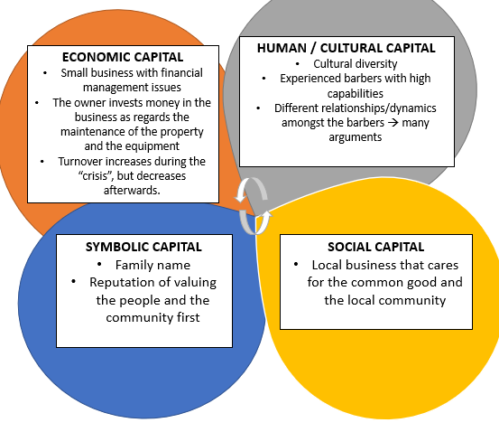

An additional model was created by the writer while working on the assignment. It is not included in the main text. However, it is added in the appendix section as advised by the professor.